

Practices for Secure Software Report

Table of Contents
Document Revision History 3
Client 3
Instructions 3
Developer 4
1. Algorithm Cipher 4
2. Certificate Generation 4
3. Deploy Cipher 4
4. Secure Communications 4
5. Secondary Testing 4
6. Functional Testing 4
7. Summary 4
8. Industry Standard Best Practices 4

Document Revision History

Version | Date | Author | Comments
1.0 | 02/21/2026 | Anthony Ashcroft

Client



Instructions

Submit this completed practices for secure software report. Replace the bracketed text with the relevant information. You must document your process for writing secure communications and refactoring code that complies with software security testing protocols.

- Respond to the steps outlined below and include your findings.
- Respond using your own words. You may also choose to include images or supporting materials. If you include them, make certain to insert them in all the relevant locations in the document.
- Refer to the Project Two Guidelines and Rubric for more detailed instructions about each section of the template.

Developer
Anthony Ashcroft

Algorithm Cipher

After analysis of the needs Artemis Financial must ensure the security of data being sent to and from its customers, I recommend SHA-256 as the encryption algorithm used to meet these needs. This encryption algorithm, while not the most robust, is strong enough to provide high collision resistance and protection from brute force decryption methods. If somehow, this data was intercepted, it would take thousands to millions of years to find the hash that would successfully decrypt this data. Using SHA-256 converts data being transmitted into something unreadable using a hash value. The data is broken into smaller chunks and transmitted to its destination. The data is then reassembled, and the checksum is checked to ensure that the results match the sending end. SHA-256 is a 256-bit cipher meaning that the hash value used to encrypt data being sent is 64 characters long.

Using random numbers in data transmission aids in the prevention of data being decrypted without the proper keys. Keys are used to ensure that encrypted data remains secure so long as the transmitter and receiver have the proper keys. Symmetric keys mean that there is a single key used on the transmission and receipt end that are used to decrypt data. An example of this is in AES-256 encryption. Asymmetric encryption means that the transmitter uses a private key for encryption and the receiver uses a public key for decryption. An example of this is in RSA and is used in web security.

Original encryption used cyphers where one letter would be converted to another letter thus making words look gibberish until the cypher was discovered. In 1970 PKIP was established which allowed for certificates to be provided to ensure communication was connected to a secure server. Eventually this gave way to symmetrical AES encryption where one key is used to encrypt and decrypt data being transmitted and RSA encryption that allowed for both public and private keys to be used in a form of asymmetric encryption. Together with secure sockets layer (SSL), transport layer security (TLS) and Virtual Private Network (VPN) connections, data has become more secure than it has ever been. Though encryption has come so far, there comes into question how it affects the government and law enforcement. Due to how complex encryption is and its difficulty decrypting without the keys, it becomes difficult for data that may be important in judicial affairs to be decrypted without cooperation from the hosts of the data.

Certificate Generation
Insert a screenshot below of the CER file.
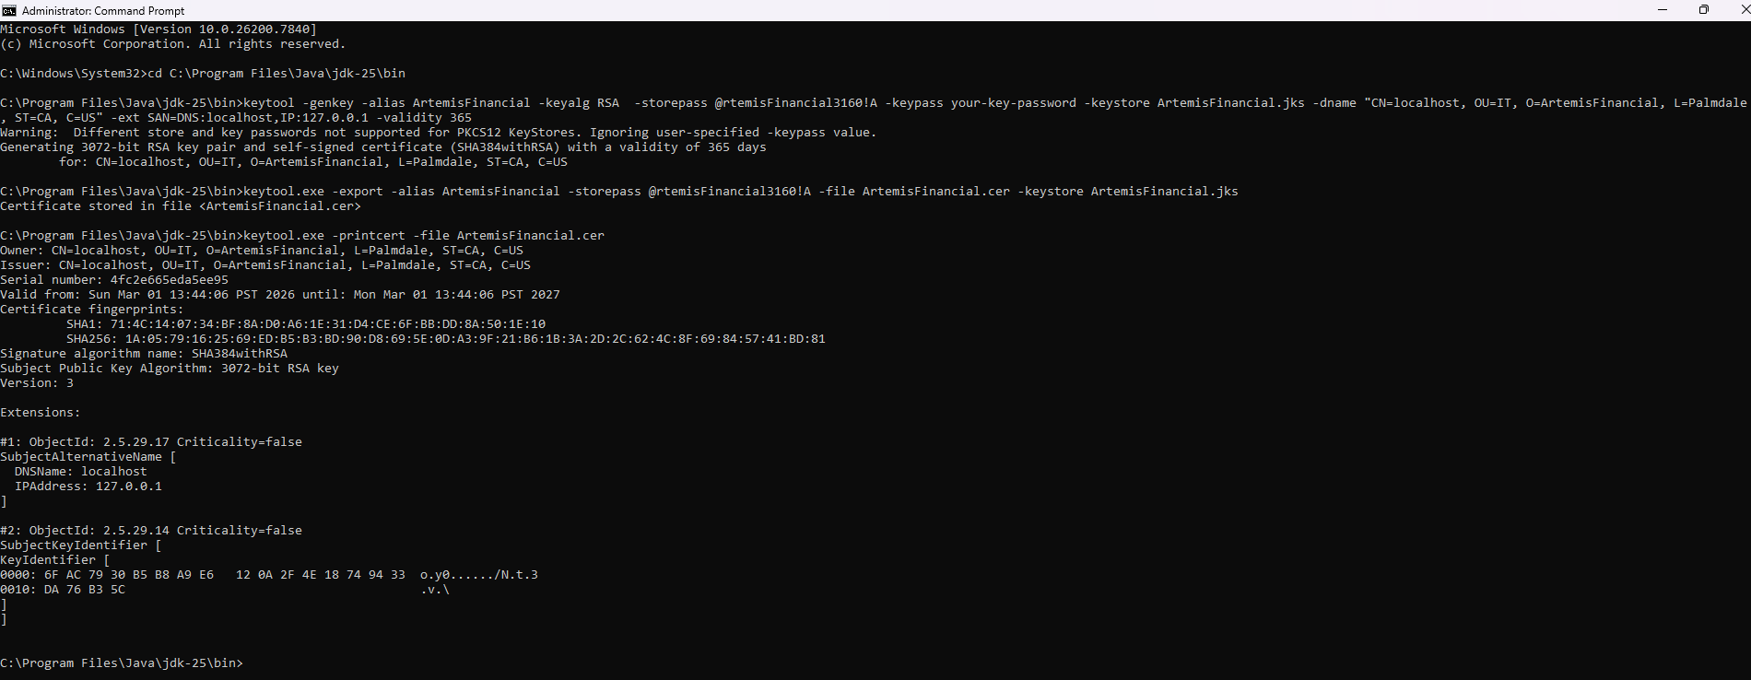

Deploy Cipher
Insert a screenshot below of the checksum verification.

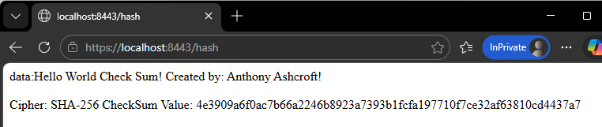

Secure Communications
Insert a screenshot below of the web browser that shows a secure webpage.

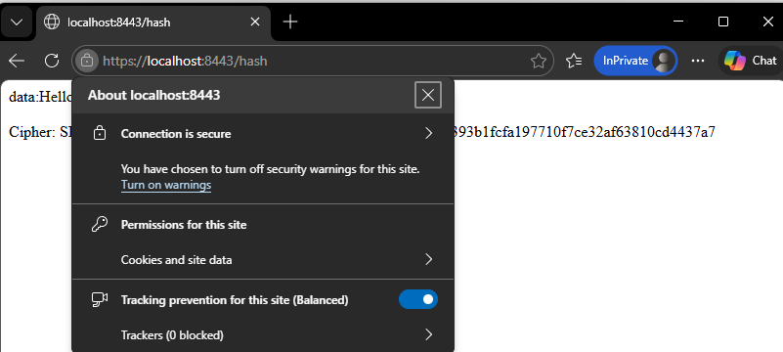
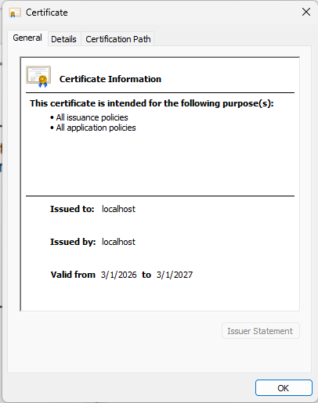

Secondary Testing
Insert screenshots below of the refactored code executed without errors and the dependency-check report.

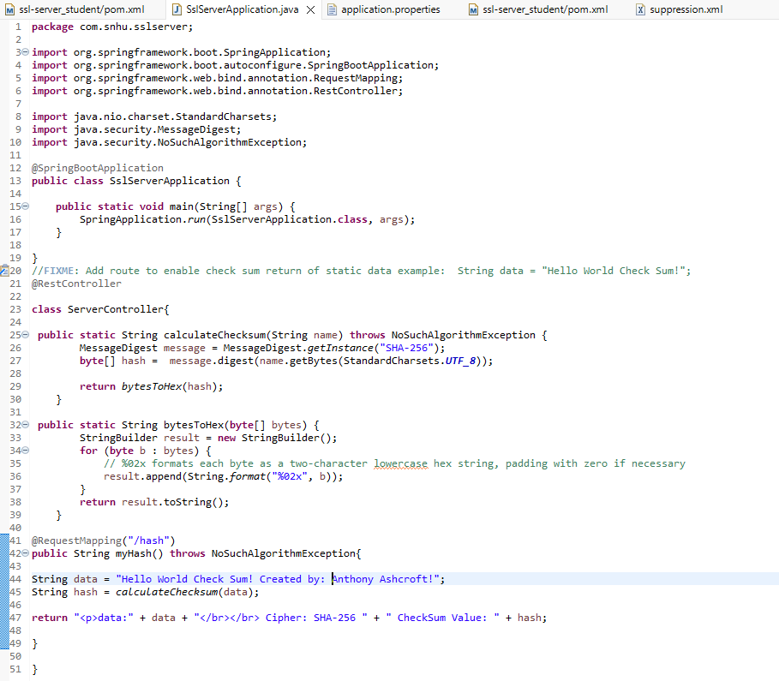
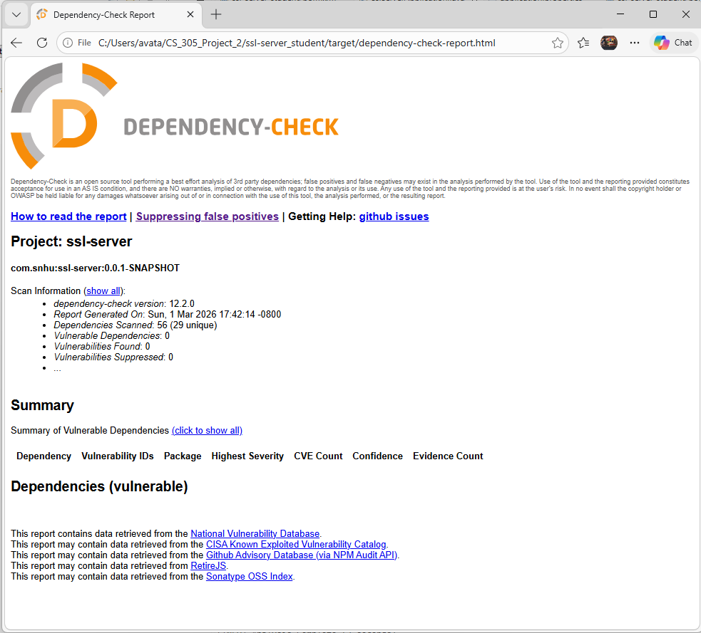

Functional Testing
Insert a screenshot below of the refactored code executed without errors.

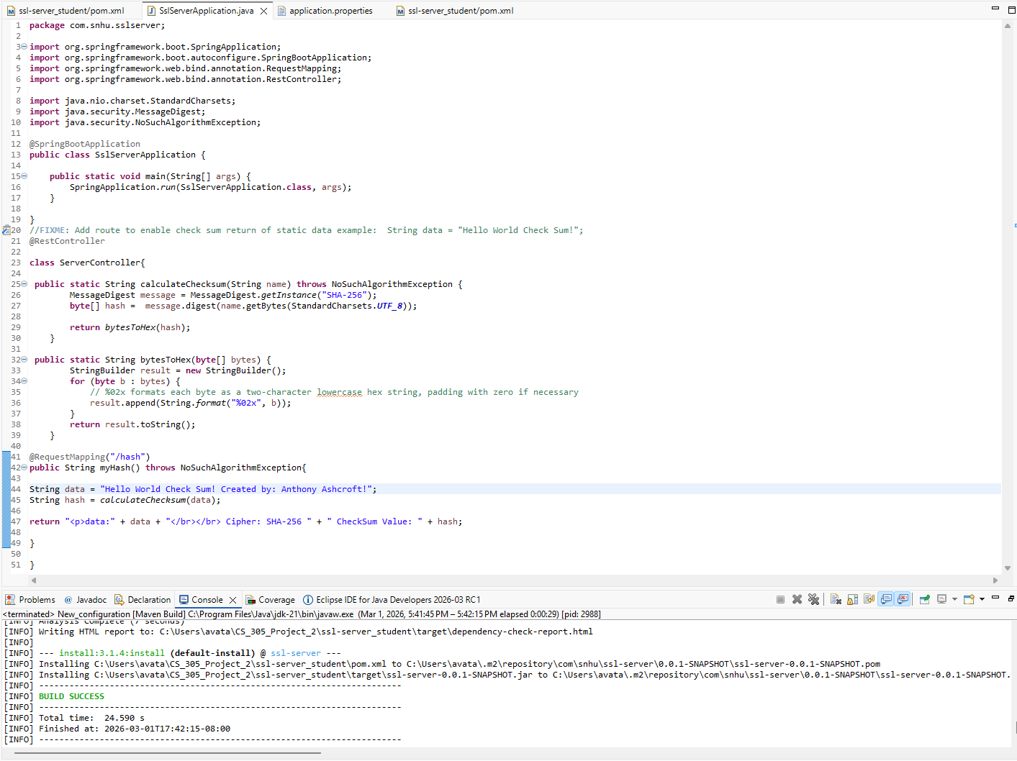

Summary

To address the security of the application, I implemented SHA-256 hash-based cryptography. This allows for secure communication between the server and the user. By providing a secure certificate, it allowed for the navigation to this server by HTTPS. Leveraging Spring Boot API provided the means for secure communication. Exception handling was also implemented to prevent attacks during checksum creation.

By adding a secure certificate and ensuring that there were no errors in code, layers of security have been added to the application to ensure secure communication with the application.

The following vulnerabilities were found applicable in the development of this application. Input validation and code error handling was used with the implementation of exception handling procedures. Using Spring Boot API provided a secure method of API access to the server. This was further improved by ensuring the most recent version of Spring Boot was implemented to move any pre-existing vulnerabilities. Cryptography was implemented using Certificates and SHA-256 hash-based cryptography. This also ensured secure client/server communication as provided by the HTTPS: protocol. Ensuring there were no errors in code compilation displays the code quality. Using the server controller class provides encapsulation that can be reused in other code development later.

Industry Standard Best Practices

By ensuring that we meet all the security vulnerability needs when developing the application, and providing clean readable code, we are following Industry Standard Best Practices. It is also important to review code regularly as new vulnerabilities might come to light. By using the dependency checker, we can find any issues that may arise and update the dependencies to re-secure the application providing the company with peace of mind that their product is as secure as it can be.

